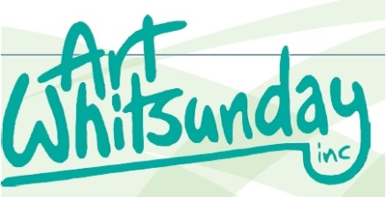

PO BOX 57
Cannonvale QLD 4802

Dear Member:

Please complete the information below if you would like to have your payments for art sold directly banked into your account. This payment will be made shortly after the month end as one payment. You will receive by email an artist payment statement which will show the details of sales and the amount deposited to your nominated bank account.

If you do not wish to have your payment paid by direct deposit please select cheque and your payment will be made available for collection at the monthly meeting following the month of sale.

It is important that the details are clear & legible as they will be used to load your account details to the bank for a direct deposit. Please print in block letters

Once your completed form has been received by the Treasurer you will be advised of your Artist Registration NO: this is to be used when you are making any direct deposits. IE membership fees, workshops etc. These forms can be left at the gallery or posted to PO BOX 57, Cannonvale QLD 4802 please make attention Treasurer.

Artist Name:

Postal Address:
Area: | Suburb: Post Code:
Phone no: | Mobile: Alternative:
Select  Method of Payment: | Direct deposit: Cheque:

Bank Account Name:

Bank Account details:  (For direct deposits only) | BSB: Account:

Signature:
Office use only: | Artist Registration NO:

